Comparative Study of Traditional Machine Learning and Transformer Model for Classification
1. Overview
The project compares two classification methods – traditional machine learning and transformer model. Both the methods are applied on a binary classification dataset of email spam classification from Kaggle. The dataset has 5573 entries each with two categories – spam or ham.
Logistic Regression and Multinomial Naive Bayes were selected as lightweight baselines. DistilBERT was selected as a pretrained transformer that can learn contextual patterns through fine-tuning. The comparison considers predictive performance, computational cost, and practical limitations.
2. Data Preprocessing
The email classification dataset from Kaggle has 2 features – Message and Category. There is no null entry in any column. 415 duplicate entries were dropped to prevent biased results, resulting in 5158 unique entries. The ham to spam ratio is 87.6:13.4. Train test split was applied with test_size=0.2 and random_state=0.42.
One-hot coding was used to convert classes into numeric form, 0 for ham and 1 for spam. TF-IDF vectorization was fitted on training data with configuration of max_features=500. Fitting the vectorizer only on training data avoids test-set vocabulary/IDF leakage. For DistilBERT, the distilbert-base-uncased tokenizer converted text to token IDs and attention masks.
3. Methodology
3.1. Traditional machine learning
The traditional machine-learning pipeline consists of text representation using Term Frequency–Inverse Document Frequency (TF-IDF), followed by classification using Logistic Regression and Multinomial Naive Bayes. These algorithms were selected because they are widely used for text classification, computationally efficient, and suitable for working with high-dimensional sparse text representations.
Logistic Regression: Logistic Regression was implemented as the first classification algorithm. Despite its name, it is commonly used for binary classification rather than regression. It learns a weighted combination of the input features and converts the resulting score into a probability of class membership. During training, the model estimates coefficients that help distinguish Spam from Ham based on the TF-IDF features. For this experiment, Logistic Regression was configured with max_iter=1000, allowing the optimization procedure sufficient iterations to converge. The model is particularly appropriate for text classification because it can handle high-dimensional sparse features and learn which words or phrases are associated with each class. However, its predictions depend on the features supplied to it and it does not inherently understand the contextual meaning of words.
Multinomial Naive Bayes: Multinomial Naive Bayes was used as the second traditional classifier. It applies Bayes' theorem to estimate the probability that an email belongs to a particular class given its observed features. The algorithm assumes that the features are conditionally independent given the class. Although this assumption is rarely completely true for natural language, the method often performs well on text-classification tasks. The model was trained on the same TF-IDF feature matrices used by Logistic Regression. Its default smoothing parameter was retained to prevent zero probabilities for features that were not observed in a particular class during training. Multinomial Naive Bayes provides a useful baseline because it is relatively fast to train and can perform effectively even with limited computational resources.
3.2. Transformer based model
The transformer-based approach uses distilbert-base-uncased, a pretrained language model available through Hugging Face. DistilBERT is a smaller, computationally more efficient version of BERT that retains many of its language-understanding capabilities. Unlike TF-IDF, which represents text primarily through term weights, DistilBERT generates contextual representations in which a token's representation can depend on the surrounding words.
Tokenization and Input Preparation: Before training, the email text was converted into token IDs using the DistilBERT tokenizer. The tokenizer maps words and word fragments to entries in a predefined vocabulary. It also creates attention masks to distinguish meaningful tokens from padding tokens. Truncation was applied to limit the maximum input length and manage memory usage.
The prepared inputs and their corresponding numerical labels were organized into a custom PyTorch Dataset. A DataLoader supplied the model with batches of eight examples. Batch processing makes training more manageable because the model processes a small group of emails at a time instead of the entire dataset in a single operation.
Model Configuration: The pretrained DistilBERT model was loaded using AutoModelForSequenceClassification with two output classes. The model was fine-tuned using a manually implemented PyTorch training loop rather than the high-level Hugging Face Trainer API. This approach demonstrates the underlying optimization process and provides direct control over training and validation. After each epoch, the model was switched to evaluation mode and the validation loss was calculated without gradient tracking.

4. Evaluation
The models were evaluated on various classification metrics like accuracy, precision, recall and F1-score to assess the performance of trained model. Precision ensures how well it is able to identify the spam email correctly. Computational cost is measured as the time required to train the model
The performance of each model is as shown:
Model | Accuracy | Precision | Recall | F1-score | Train time (sec)
Logistic Regression | 0.9632 | 0.9592 | 0.7344 | 8319 | 0.07
Naïve Baye’s | 0.9622 | 1.0 | 0.6953 | 0.8203 | 0.01
DistilBERT | 0.9884 | 0.9915 | 0.9141 | 0.9512 | 2932.08

It is observed that the transformer model performs best with its self attention mechanism, although consuming a long training time and is computationally costly. While Naïve Baye’s is computationally cheap, it sets a sufficient threshold for other models.

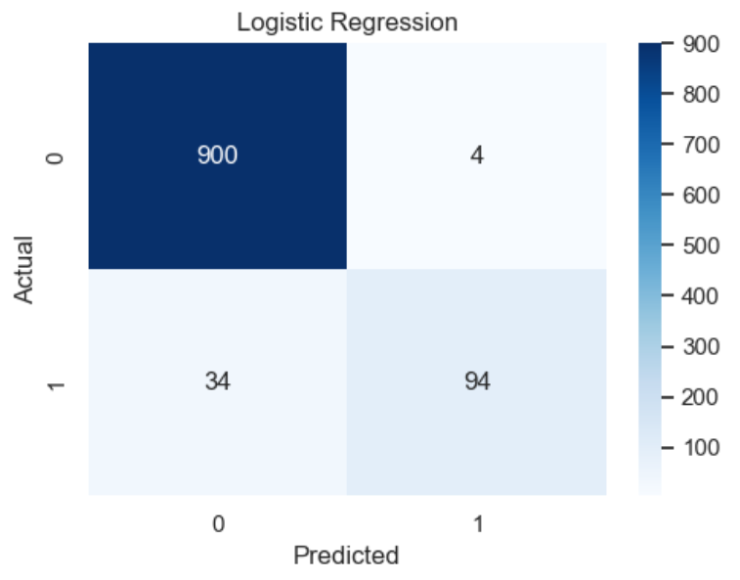
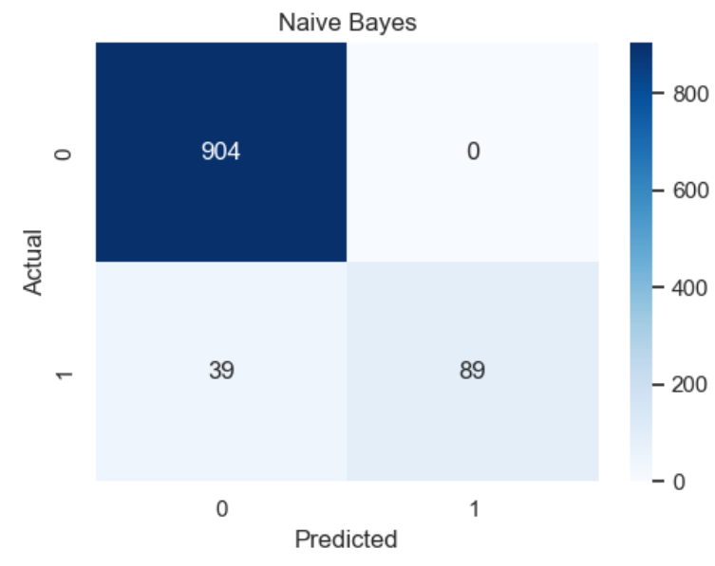
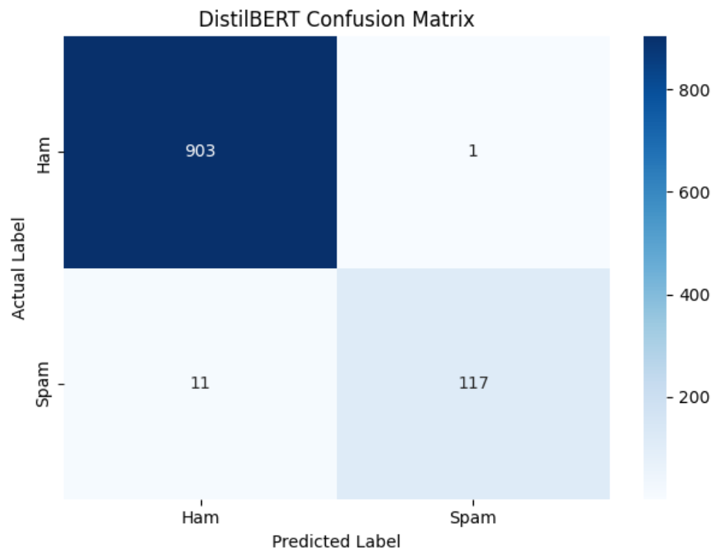

5. Limitations
Dataset Dependency: Model performance depends on the dataset's size, quality, class distribution, and diversity. Results may differ on real-world emails.
TF-IDF Limitations: TF-IDF focuses on word frequency and importance but does not fully capture context, word order, or semantic meaning.
Model Assumptions: Logistic Regression may not capture complex patterns, while Naive Bayes assumes conditional independence between features.
Computational Cost: DistilBERT requires more memory and training time than traditional machine learning models, requiring faster CPU or GPU.
Limited Generalization: The models were evaluated on a specific test set and may not perform equally well on new or evolving spam messages.
Deployment Challenges: Real-world use requires considering inference speed, resource consumption, and the consequences of incorrectly classifying legitimate emails as spam.

